**AquaSaver: Conserving Water with Fog Disinfection Handwashing**

Ram Yalmate 1, Om Kaldate 2, Sudarshan Biradar 3

*Electronics and Telecommunication department*

*Vishwakarma Institute of Information Technology, Pune, Maharashtra*

[ram.22210233@viit.ac.in](mailto:ram.22210233@viit.ac.in)

[om.22320039@viit.ac.in](mailto:om.22320039@viit.ac.in)

[sudarshan.22320211@viit.ac.in](mailto:sudarshan.22320211@viit.ac.in)

Initialize LCD & Print

**III. BLOCK DIAGRAM**

No

Yes





***Abstract — In our effort to promote hand hygiene amidst the COVID-19 pandemic, we introduce a system designed to encourage regular handwashing in public areas. This system utilizes components such as a buzzer, LCD, LED, and the ATMEGA328P microcontroller to facilitate automated handwashing procedures. The ATMEGA328P microcontroller coordinates the operation of the system, while the buzzer and LED provide alerts and feedback to users. Additionally, the LCD displays important information to guide users through the handwashing process. By integrating these components, our system aims to promote effective hand hygiene practices in public spaces.* Programming part of microcontroller is done using C language.**

***Keywords — Hand hygiene, Public health, Automated handwashing, Microcontroller, Buzzer alert, LCD display, LED indicator***

IR Input

**I. INTRODUCTION**

In our mission to combat the coronavirus pandemic, we've devised an innovative approach to promote hand hygiene, particularly in areas facing water scarcity. Our solution revolves around a groundbreaking machine that converts water into a mist, facilitating effective hand cleaning while conserving precious water resources. Central to this system is the 89S52 microcontroller, which serves as the backbone, coordinating the operation of essential components like the buzzer, 16x2 LCD, and LED.

Fog Maker On

These components work in harmony to streamline the handwashing process, providing intuitive feedback and guidance to users. The buzzer emits audible alerts, signaling the activation of the misting system when a hand is detected. Simultaneously, the 16x2 LCD displays clear instructions, while the LED indicator offers visual cues, ensuring a seamless handwashing experience. With this innovative technology, we aim to empower individuals to maintain optimal hand hygiene practices, contributing to the collective effort in curbing the spread of the virus and safeguarding public health.

LCD Print

Remove Hand

**II.DESIGN AND IMPLEMENTATION OF THE SYSTEM**

Our handwashing system seamlessly promotes effective hand

hygiene with additional features for enhanced user experience.

Upon hand detection by the infrared sensor, the mist maker

sensor activates, releasing a fine mist for disinfection.

Simultaneously, the buzzer emits an audible alert, while the

LED provides continuous illumination throughout the handwashing

process. After a few seconds of mist generation, the DC motor fan,

controlled by a motor driver, activates to dry the hands. This

coordinated functionality, managed by the 89S52 microcontroller,

ensures a user-friendly and efficient handwashing experience, further

contributing to public health and water conservation efforts.

**IV. STRUCTURE AND COMPONENTS**

**1.1 MICROCONTROLLER:- Atmega328P**

The ATmega328P, a popular 8-bit microcontroller from Microchip Technology, follows a Harvard architecture, similar to the 89S52. This means it has separate memory spaces for program instructions and data. Its core is an 8-bit AVR RISC processor, capable of executing instructions at speeds up to 20 MHz. It boasts 32 KB of Flash memory for storing program code, 2 KB of SRAM for volatile data, and 1 KB of EEPROM for non-volatile data storage.The ATmega328P is equipped with 23 general-purpose I/O pins that can be configured for input or output, enabling interaction with external devices. Three 8-bit timers/counters provide timing functionality and facilitate pulse width modulation (PWM) for controlling motors or LEDs.

**1.2 Fog Maker/Machine with Piezoelectric Mist Maker Sensor**

A fog maker, or smoke machine, is a device that creates thick smoke similar to fog or smoke. It's often used for fun at parties or events, but can also have practical uses in industries like education or entertainment. Normally, fog is made by heating special liquid, but in our system, we've added something special called a piezoelectric mist maker sensor. When this sensor touches water, it magically turns it into mist. This means we can make fog without needing to heat up any liquid, making it simpler and safer.

**1.3 Water Tank for Mist Sensor**

The water tank is a simple bowl-like container designed to hold water. In our system, we use it as a base for the mist sensor. By placing the mist sensor in the water tank, we provide it with a steady supply of water to generate mist. This setup allows the mist sensor to efficiently create mist without the need for complex liquid systems or heating mechanisms. It's a straightforward and practical solution for ensuring the mist sensor can operate effectively and continuously.

**1.4 LCD**

LCD (Liquid Crystal Display) screen is an electronic display module and find a wide range of applications. A 16x2 LCD display is very basic module and is very commonly used in various devices and circuits. These modules are preferred over seven segments and other

multi segment LEDs. The reasons being: LCDs are economical; easily programmable; have no limitation of displaying special & even custom characters (unlike in seven segments), animations and so on.LCD display is very basic module and is very commonly used in various devices and circuits. These modules are preferred over

seven segments and other multi segment LEDs. The reasons being: LCDs are economical; easily programmable; have no limitation of displaying special used in most embedded projects, the reason being its cheap price, availability and programmer friendly. & even custom characters (unlike in seven segments), animations and so on.LCD modules are very commonly

**V. RELATED WORK**

Different methods have been explored to tackle the challenge of saving water while washing hands effectively. One method involves using fog disinfection, which is like fogging systems used in various places for cleaning. This system creates a thick fog or mist by evaporating water mixed with a special liquid. The mist disinfects surfaces by condensing into visible fog when it mixes with cooler air. This approach helps in cleaning hands without using too much water, but it's not widely used for personal hygiene yet.

Another way to save water during handwashing is by using piezoelectric mist maker sensors. These sensors turn water into mist when touched, making handwashing efficient and conserving water. Additionally, motion or proximity sensors can automate the mist-making process when they detect hand movement.

Although fog disinfection and mist maker technologies show promise for water-saving handwashing, more research is needed to improve and make them more accessible. Future work could focus on creating small, easy-to-use handwashing devices for homes, public places, and healthcare settings. Also, making sensors more sensitive and efficient can further enhance water conservation efforts and hygiene practices.

**VI. CIRCUIT DESIGN**

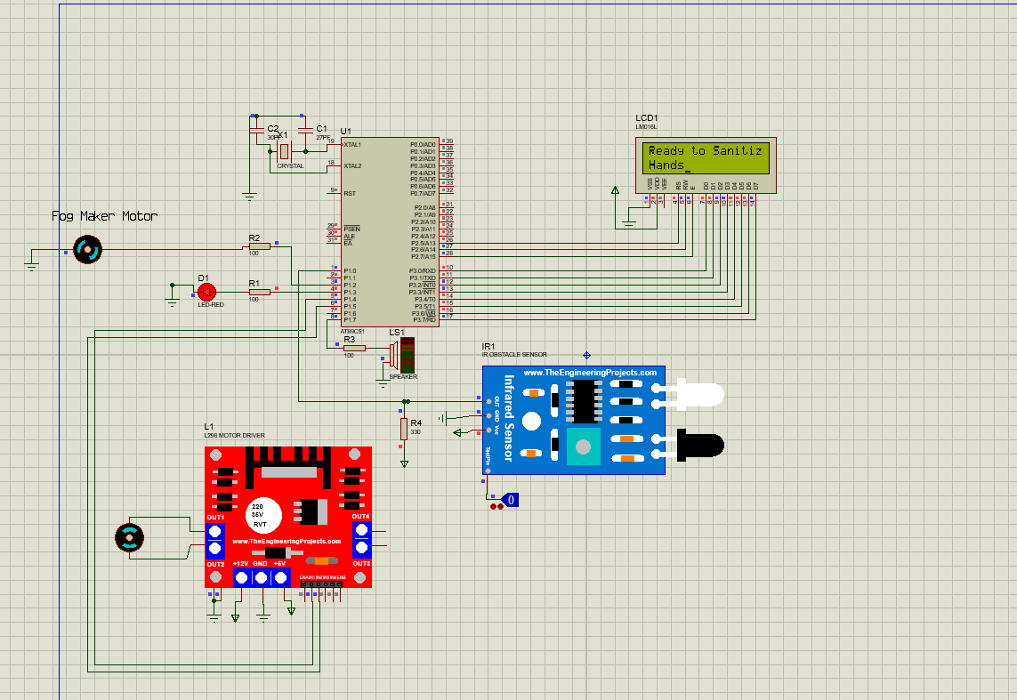

Fig 5.1 Schematic diagram

**2 METHODOLOGY**

STEP 1: Start

STEP 2: Initialize LCD display for showing current status of hands are sanitized or not

STEP 3: Set the input IR for sensing

STEP 4: Check for the activation of Fog Maker. If the Fog Maker is activated go to step 4 and step 5 otherwise repeat step 3

STEP 5: The Disinfectant Solution is converted into the Fog.

STEP 6: Fog is transferred to the Hand Chamber.

STEP 7: We are ready to get our Hand Sanitized.

STEP 8: Check for the hand got sanitized by the machine. If the hand is sanitized go to next step.

STEP 9: Turn on the fan for drying hands

STEP 10: When the process is done the machine will stop

STEP 11: Display the lcd that remove your hands lease remove hands

Step 12: machine waits for 5 seconds for getting system ready and this shows on LCD display

STEP 13: go to step 1

**VII. RESULTS AND CONCLUSION –**

The proposed work has many important advantages and helps to kill viruses and bacteria in public places such as train stations, airports and theaters. Good hygiene is helpful as it is a non-contact approach that helps maintain proper social distancing in line with general standards. Its portable design makes it easy to install and use in a variety of locations depending on your needs. The technology used is still new and very unstable. Using about 95% less water than traditional hand washing, it solves one of the biggest water saving problems, which is why we see progress and new products on the market with a similar mechanism. Use less than 95% of the water needed to wash your hands using conventional faucets. The saved water can be used for other purposes. The system is fully automated and avoids manual mistakes such as opening the tap, tap leaks and maximizing water savings. With this mechanism, the installation and maintenance of existing faucets is no longer a problem, people can operate them comfortably, contactless and very hygienic.

**AKNOWLEDGEMENT**

We extend our heartfelt appreciation to all individuals who contributed to the successful completion of this project. We are especially grateful to P.G. Gawande for their invaluable guidance, support, and expertise throughout this endeavour. Their insightful advice and constructive feedback played a pivotal role in shaping the direction and outcomes of our project.

We also wish to convey our gratitude to the dedicated members of our research team for their unwavering commitment, hard work, and collaborative spirit. The collective efforts and diverse talents of each team member have been instrumental in achieving the project's objectives.

***References***

[1] WHO, “Who Save Lives : Clean Your Hands in the Context of Covid-19,” no. May, pp. 19–20, 2020

[2] Taddese, B. Dagnew, H. Dagne, and Z.Andualem, “Mother’s Hand washing Practices and Health Outcomes of Under-Five Children in Northwest Ethiopia,” Pediatric Health, Medicine andTherapeutics, vol. 11, pp. 101–108,2020.

[3]. A. Patel, “Preventing COVID-19 Amid PublicHealth and Urban Planning Failures in Slums of Indian Cities,” World Medical and Health Policy,pp. 1–8, 2020.

[4]. J. B. Sy, M. G. Rojo, E. R. Calibara, A. V.Comendador, and W. Degife, “Multi-Station Automated Hand Washing System ( MSAHWS ),”no. 3, pp. 36–43, 2020.

[5] M. Alzyood, D. Jackson, H. Aveyard, and J. Brooke,“COVID-19 reinforces the importance of hand washing,” Journal of Clinical Nursing, pp. 1–2,2020.